Executive Summary

Provide a brief overview of the product concept, including its purpose, target audience, key features, and why you think it should be integrated.

This document introduces some UI enhancements and a new feature to create a project from the extension with minimal number of clicks and time spent. These changes will be relevant for all Haibrid users and are aimed to enhance the current version of Haibrid web extension by making it more intuitive.

Target Release | -
Epic | Browser Extension Epic:  HAIB-237  Ticket List:  HAIB-823  HAIB-824
Document Status | {READY}
Owner | Tatevik Azoyan

Objective
Provide context on this feature and explain how it fits into our organization's strategic goals

To reduce friction and enable instant & ongoing value by removing the additional steps required to go back and forth to the main Haibrid page to create a new project.
By adopting easier project creation from extension we aim to increase project creation done on the platform (overall), resulting in less hustle later organizing projects and sources on the website.

Assumptions
List any assumptions you have about your users, technical constraints, or business goals (e.g., Most users will access this feature from tablet)

- Assumingly, significant amount of new users will start using Haibrid from the extension right after extension installation. Thus, the correct way of user workflow is from the extension to the website, and not the other way around. If there is no ability to add a project from the extension, users may initially clutter a lot of sources in the unassigned sources section, and that will create additional hustle when they try to manage sources on the website later, which will result in low retention.
- Users may come across a completely new topic of interest while browsing and feel the urge to save it to a new project (not yet existing).
- Users prefer products with minimal cognitive load and intuitive design that involves familiar icons, tooltips and guiding action texts.
- Users often use the extension to save the source when they are short in time and need to have combination of quickest and fullest experience possible.

Success metrics
List project goals and the metrics you'll use to judge its success

Goal | Metric
Simplify the user experience | Customer satisfaction score of extension increases
Incentivize users to add more projects and use Haibrid more often | - Number of projects created through extension increases and number of projects created overall increases  - Usage of Haibrid extension increases

Requirements
Describe functional requirements here:
- Description
- Requirements

- As a user, I want the ability to open the extension either by clicking on pinned Haibrid icon or by Right Click -> Save to Haibrid, with option to edit default source name and add notes and specify a project before saving.
- When opening the extension in any way, “Unassigned Sources” should appear as the default project to save the source to, and there should be a dropdown icon.
- Users should be able to edit the source name by clicking on edit icon or anywhere on the name.
- Users should be able to input any symbols in the Note section with no character limit. A scroll should appear within the Note field if the input is too long. Users should be able to expand the Note field by dragging them // icon in the right lower corner. The input in “Note” section shouldn’t change regardless of project selection.
- Need to add a limit on how long the Note field can be expanded to. ?

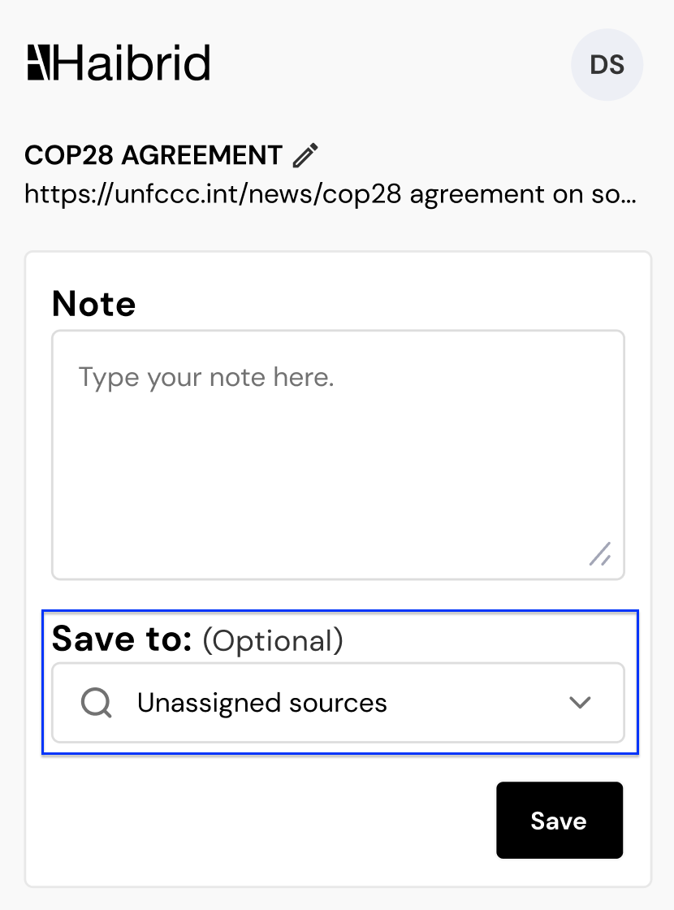

- As a user, I want to have simplified experience of saving the source to a project:
- When clicking anywhere on the Project Search Bar and if there are no characters input, the last 3 projects a source has been added to should appear in the dropdown, ordered by recency.
- When selecting any other project other than “Unassignes sources”, the selection should be reflected in the “Save to” search bar and dropdown should close.
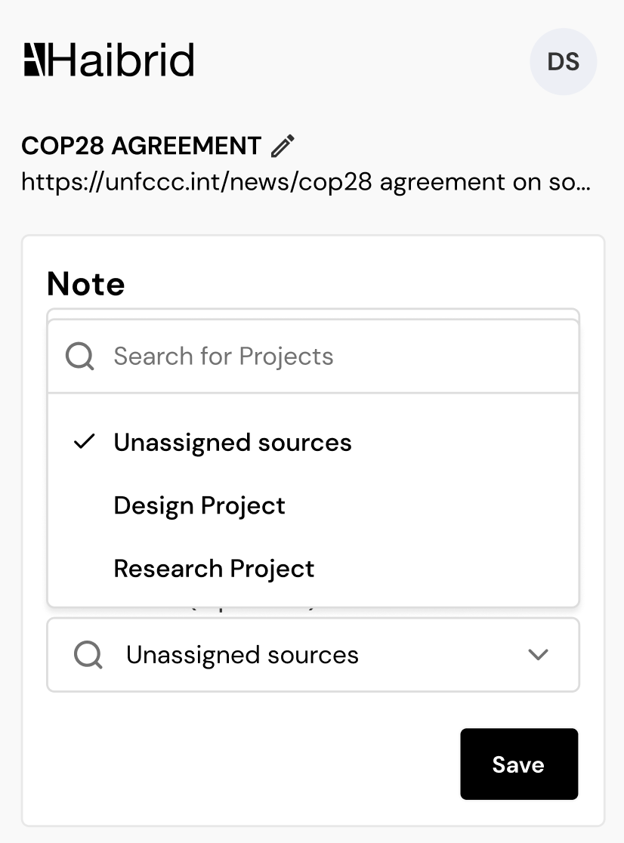

- As a user, I want the ability to quickly create new projects in the extension itself:
- User should be able to type in anything in the search bar.
- When typing the name of a project, even if there is 1 symbol typed in, the “Add Project” button should appear as the 4th option.
- When clicked, a new project should be created immediately, dropdown should close, and newly created name should appear as the project selection instead of “unassigned sources”.
- This new project should immediately appear on the user’s main dashboard.
- There should be a checkmark near the selected option when reopening the project dropdown.
- There is no need to make “Unselect” or “Delete” option, users should always be able to re-select or create another project. Unassigned sources should always be shown in the dropdown in spite of recency.
- If there are more than 5 project suggestions based on the search results, only 5 of them should be visible at once and a scroll should appear (like it is done for the “Save to Haibrid” version of extension)

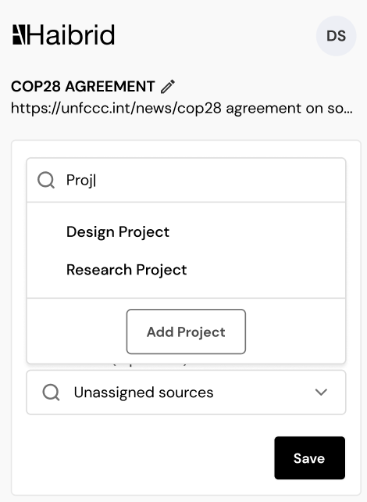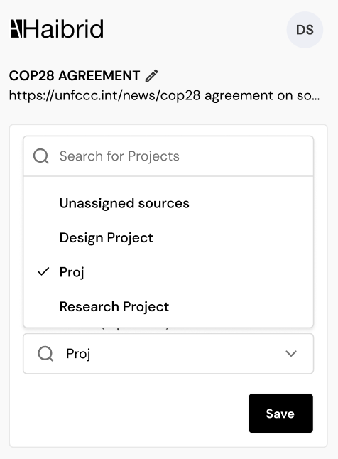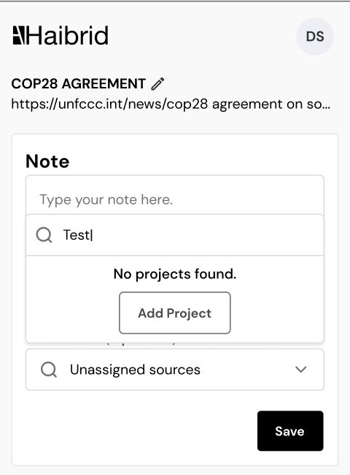

All changes should be saved to main dashboard immediately and dropdown should close after clicking on save.

User interaction and design
Add mockups, diagrams, or visual designs related to these requirements. Either past a figma link to the flow, or past screenshots if not many.

Main frames and sizes of the extension should remain the same way as they look in the current version, there should be slight differences in the extension experience based on how we open it:
- When the user clicks on the Haibrid icon to save the source, the UI should look like designs in the first row of “Adding a project from the extension flow”
(i.e. extension window should be relatively narrow and the project dropdown should be opened above the “Save to” field).
- When the user saves by right click -> “Save to Hibrid -> Edit to save the source, the UI should look like designs in the second row of “Adding a project from the extension flow”
(i.e. extension window should be wider and the project dropdown should be opened below the “Save to” field).

Mockups for the complete flow can be found here:
https://www.figma.com/design/iatgnQk87zdDBm26E0i6yP/Haibrid-DS-v1.1?node-id=14204-46926&t=ZIXhBm02Djx1r0Xq-4

Out of Scope
List the features discussed which are out of scope or might be revisited in a later release.

- Allow editing existing project name from the extension.
- Suggesting names for the new project (may be some AI integration)
- Allow deleting projects from the extension (need to ask validation question before deleting)

